AM000-Asia-China-Warring States-Four Boss-Eight Arc-Twelve Character-475-221 BCE

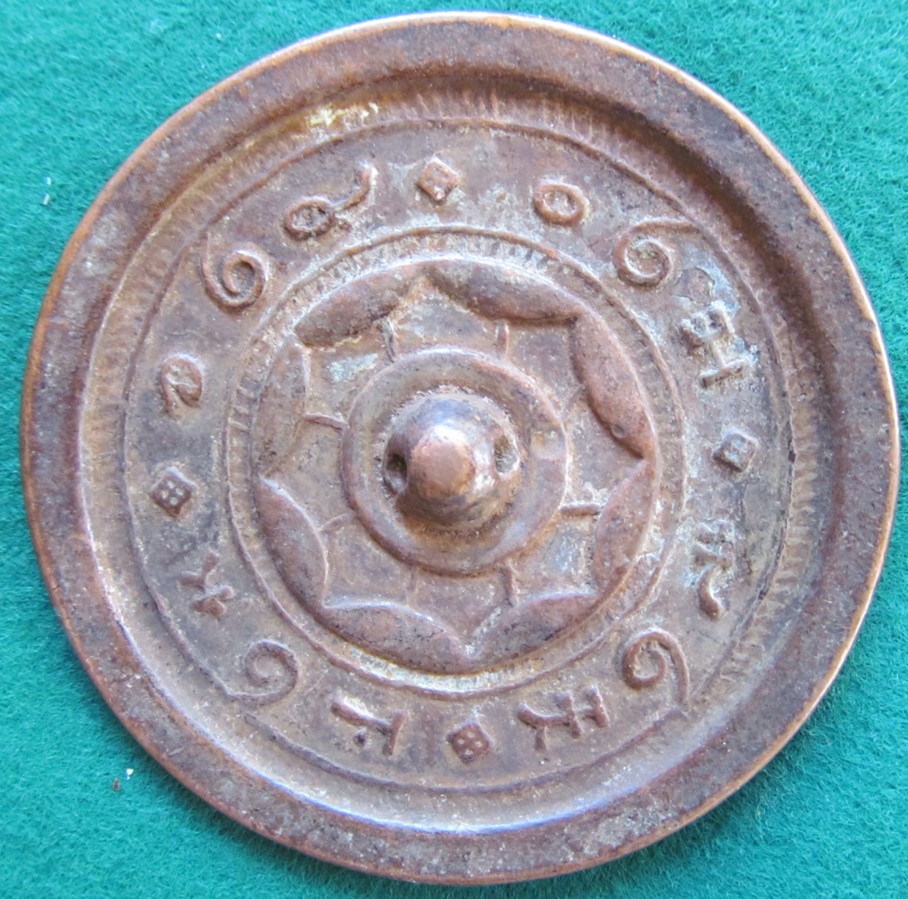

This mirror features a 12 character inscription broken into 4 three charater sayings in ancient Shang script. Its 8 continuous arcs are linked with lines to the central boss..